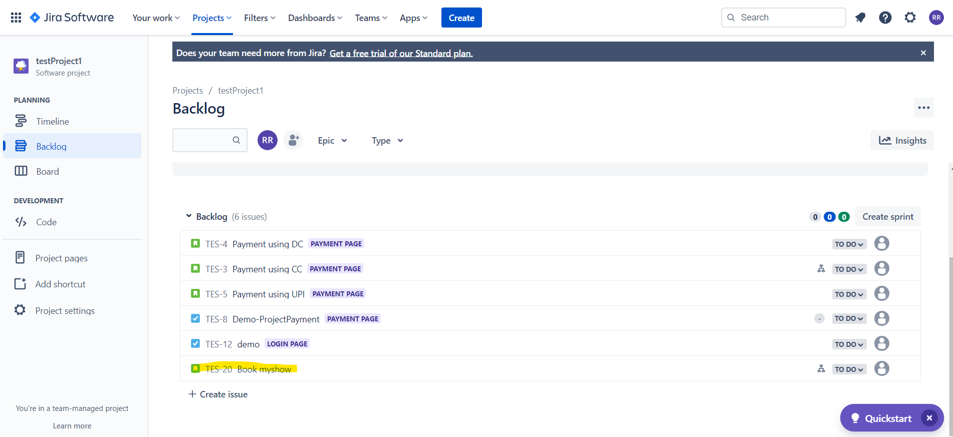

**Creating the story for Bookmyshow app**

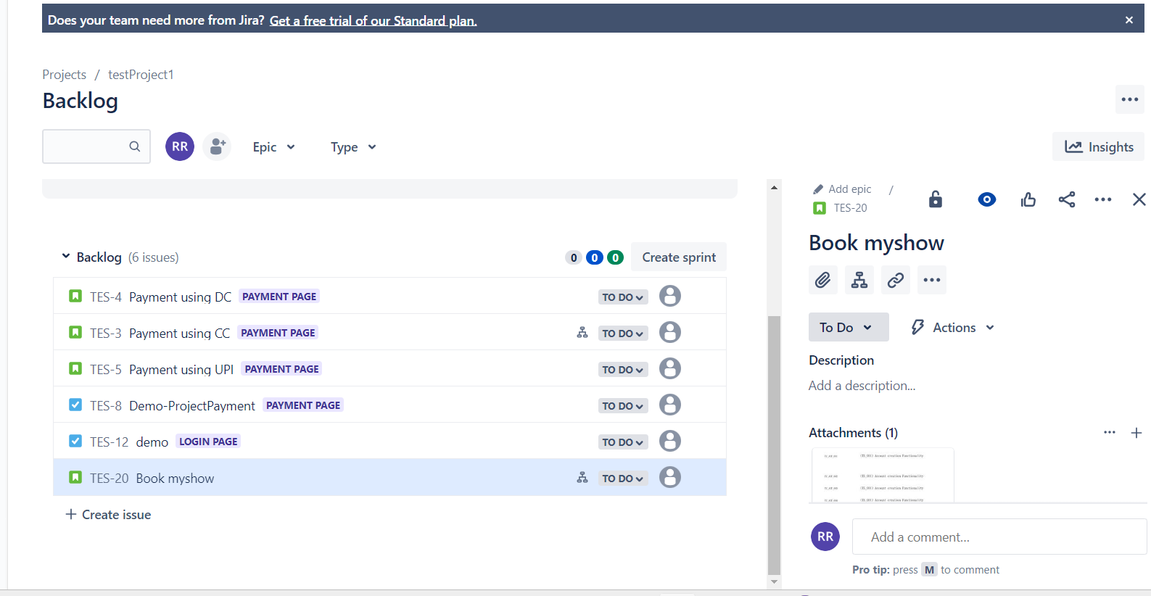

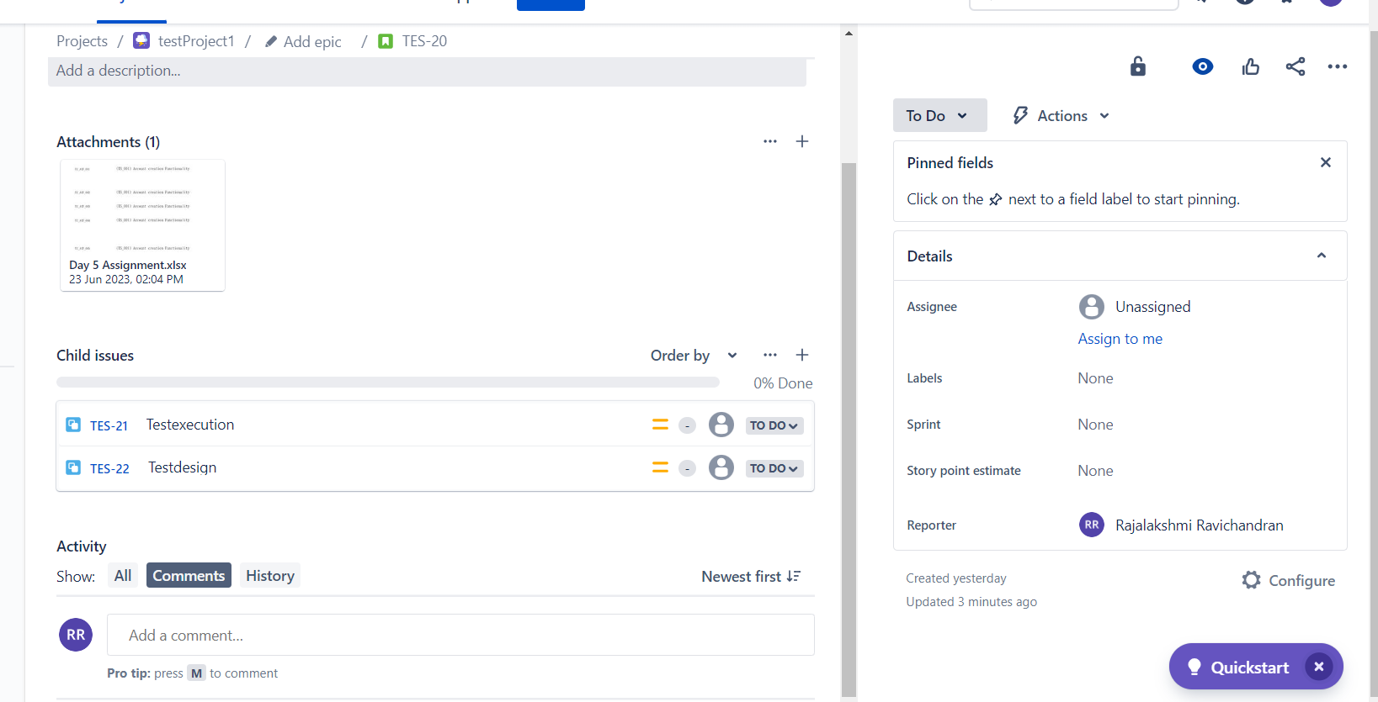

**Create the child issues**

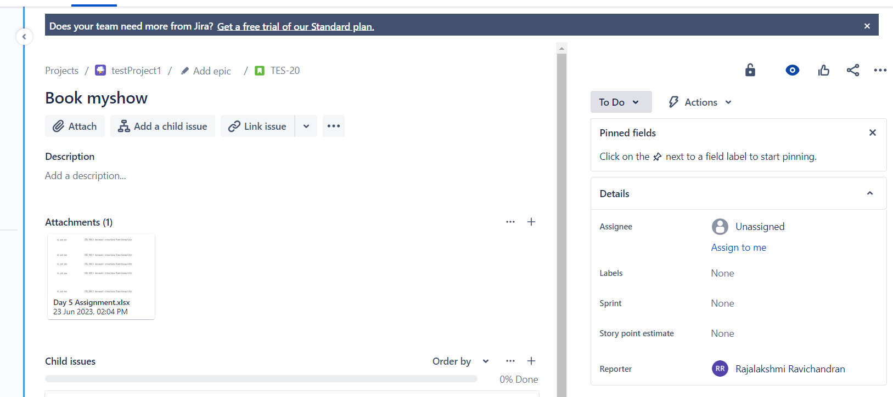

**Make the attachment**

**Q2.Keypoints on test Scenario, test case , test plan and summary report**

**Test Scenario**

**A possible area to be tested**

**Test Case:**

**Step by step actions to be performed to validate the functionality**

**Test plan:**

**Test plan includes overview, scope, inclusion , exclusion , test environment**

**Test strategy, defect reporting, roles, deliverables etc…**

**Summary report:**

**It provide all the data we worked on during the project overview of our work.**